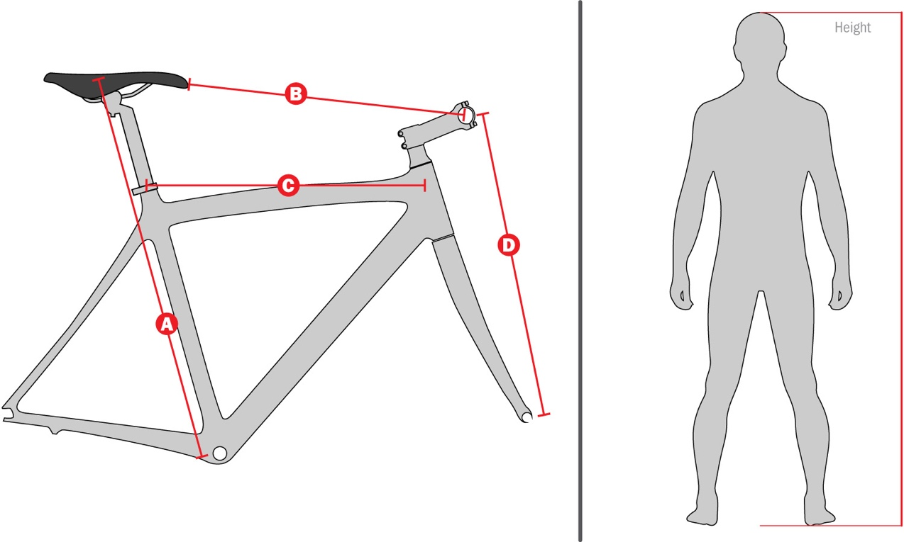
If you are hiring a bike please complete the details below to the best of your ability.
REMEMBER: bring your pedals with you. You may also wish to bring your saddle, if it is the only one you feel comfortable on.
To complete the form just start typing, and use the TAB key to navigate through the form. Use the Space Bar or Cursor to check/uncheck a check box.
Name
Tour / Dates
Your Height
A
B
C
D
FRONT BRAKE | LEFT OR RIGHT on handle bars
PLEASE RETURN FORM BY EMAIL TO: info@one-more-ride.com

